PPO ( Proximal Policy Optimization)

Policy Loss Formula

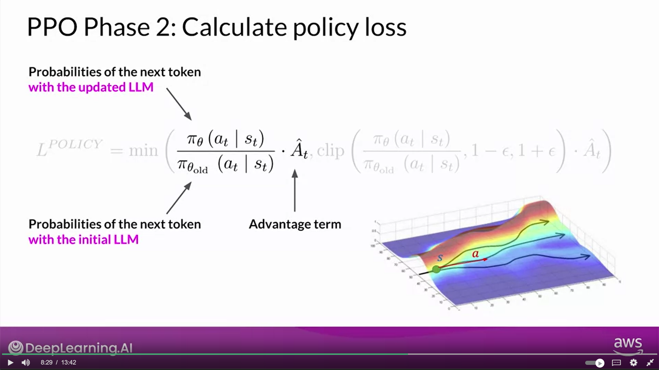

Entropy Loss

Higher the entropy, more creative the answer will be. This is similar to the temperature settings in LLMs.

PPO Objective Function

